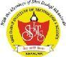 **Shri Dadaji Institute of Technology and Science**

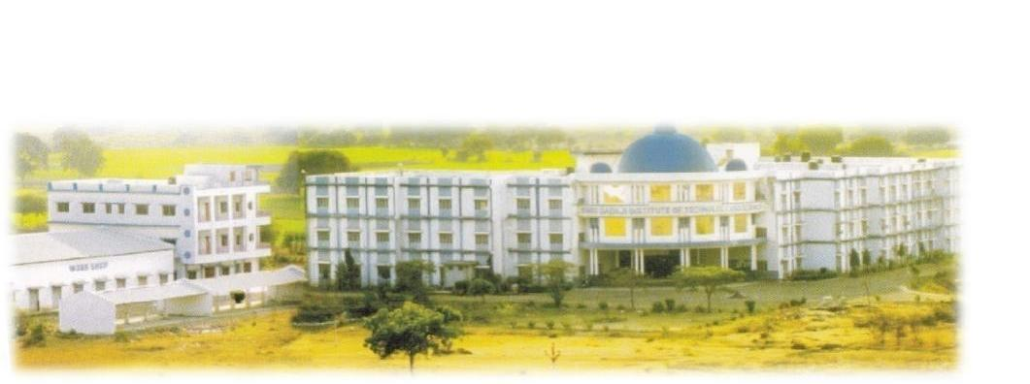

**The College:**

**Affiliation: AICTE, Delhi and RGPV, Bhopal.**

**Contact No: 9424557595, 0733- 2243488**

**Email Id: placement.sdits@gmail.com**

**Website: www.sdits.org**

**Address: Indore Road, Rehmapur, Khandwa – 450001 (M.P.)**

**Shri Dadaji Institute of Technology & Science, Khandwa is one of the leading private Technical and Professional institutes in Madhya Pradesh today, having campus in lush green out skirts of Khandwa. The first ISO 9001:2000 Certified Technical Institute in East Nimar Region was started in 2004. Institute functions under the patronage of Dadaji Dhuniwale Professional Education & Development Co-operative Ltd., Khandwa & is managed by Technocrats who have excelled in their respective profession. Since inception it is endeavoring for the quality and excellence in the technical education. All the courses of the institute are approved by AICTE Delhi, Govt. of India. Department of the Technical Education, Govt. of M.P. and are affiliated to Rajiv Gandhi Proudyogiki Vishwavidyalaya, Technical University of Madhya Pradesh.**

**In its span of 10+ years the institute has developed into a leading engineering and professional college in the region with state of the art infrastructure, faculty members and facilities. Performing well in University Exams and student are already placed in MNC's and performing well in reputed national /International industries and universities.**

**The institute is committed to excel in areas of engineering, technology and management by enhancing its facilities, highly qualified and committed faculty drawn from reputed academic institutions of the country and repute & senior professionals from industry as well the instate benchmark against top engineering college's in India.**

**Founder Chairman of society, Late Shri Tanwant Singh Keer (Ex. State Minister), has putted his effort to promote quality education along with Shri Rana Sajjan Singh an Agriculturist. The team is structured by Shri Rana Sajjan Singh as Chairman; Smt. Anima Ubeja (Ex. Mayor, Khandwa) as Treasurer.**

**Infra-structure**

**The college campus has more than 10 acres of land for its overall development. The main building of college has majestic and attractive look and covers about 1, 20,000 sq ft and of 50,000 sq.mt is in progress. The building is considered to be one of the finest in the area and surrounded by nature creating good environments of study.**

* **Nearby Airport : Devi Ahilya Bai Holkar Airport , Indore (M.P.) {120 KM away from Khandwa}**
* **Nearby Railway Station : Khandwa Junction { Bhusawal Division}**

**Institute offers:-**

**4 year B.E Program**

**Computer Science & Engineering (Seats -120)**

**Department comprises with full equipped software development labs, computer Networking lab and Linux labs all the laboratories are equipped with various latest software and current hardware configurations. The available software are Windows 7 ultimate Windows 2008 Server, Red Hat Linux Enterprise, JAVA, TC++, Visual Studio 8.0, Oracle11g, Linux, Novell Netware, Microsoft Office 2007,10 etc. All laboratories are provided with 15 KVA UPS system to provide uninterruptable power supply. The Department looks after the computer maintenance of the entire campus of the institute; the Department is a broad discipline that employs a variety of approaches in an effort to advance our understanding and use of computing, the department focuses on development and strengthening system thinking, problem solving, analysis, design, research, team work, communication skills, and readiness for lifelong learning.**

**Electronics & Communication Engineering (Seats - 60)**

**The department of EC acquires a unique standing among the other departments. It has state of art labs and experimental setups, which reduces the differences between institute and industry. Students are given facilities to work on latest technologies in the following labs VLSI lab, Optical Communication Lab, Circuit designing project workshop, Antenna lab, Microwave Engg. Lab, Microprocessor & Micro Controller lab, data communication lab, Analog & digital Comm. Lab., Electrical devices & circuit lab, T.V. lab, Instrumentation & measurement lab, Software lab for VHDL and Mat lab, Communication Network & Transmission lines lab, Electronics lab.**

**The department has taken development as a continuous process and assured this through its mission. The department has blend of senior, young and dynamic staff.**

**Electrical & Electronics Engineering (Seats- 60)**

**Electrical Engineering is the branch of engineering science that studies the uses of electricity and the equipment for power generation and distribution and the control of machines and instrumentation. Electrical and electronics engineering, the branch of engineering concerned with the practical applications of electricity in all its forms, including those of the field of electronics. Electronics engineering is that branch of electrical engineering concerned with the uses of the electromagnetic spectrum and with the application of such electronic devices as integrated circuits, transistors, and vacuum tubes.**

**The department is equipped 24 hour net facilities for the students in the high tech labs Power system Lab, Electrical Machine Lab, Basic Electrical and Network, Software Lab equipped with dedicated LAN connections. Apart from specific technical knowledge, electrical and electronic engineering students gain a variety of transferable skills through following their degree programme.**

**Mechanical Engineering (Seats-60)**

**Mechanical engineering is a broad field of engineering that involves the use of physical principles for analysis, design, manufacture and maintenance of mechanical systems. Engineering Mechanics Lab, Kinematics of Machine lab, Basic Mechanical Engineering Lab, Dynamics of Machine Lab, Fluid Mechanics Lab, Heat Engine Lab, CAD/CAM Lab, Machine shop equipped with radial drill machine, Shaper Machine, Lathe machine, power Hacksaw machine etc. Workshop has fitting shop, Carpentry shop, Maudling shop, Pattern shop, Welding shop.**

**The Department is committed to prepare effective and responsible graduate engineers for global requirements by providing quality education. Keeping itself up to date with the latest developments and trends in the field.**

**Civil Engineering (Seats- 60)**

**Civil Engg. Department of the institute has well furnished labs with modern equipments. Department has well qualified experienced & dedicated faculties & staff. It also provides consultancy services like material testing, surveying, structural designing etc for all types of civil engineering structures.**

**Department looks after overall development of its students. As a result of these efforts students from the department consistently perform well in academics, sports and other activities. Students participate actively and excel in technical seminars, workshops, sports etc. The department has been pro-active in interaction with the industry to familiarize the students and faculty with the latest technologies and trends.**

**The Department consists of experienced and skilled faculties to guide the students in the right way to develop the career.**

**3-Yrs MCA Program (Seats-60)**

**The Department has always been on the path of progress, equipped with experienced and dedicated faculties each with a highly qualified degree and has strong communities to technical education. Department has sophisticated and excellent air conditioned computer labs. Main lab equipped with LCD projector, multimedia kit, printers and advanced computing Lab facilitated with TFT screen. Home directories for all users are available to any machine through NFS and Samba. Internet website, FTP server, MYSQL server services are running on LINUX Pentium IV system. Main lab equipped with 100 mbps switched network. All systems [servers & clients] are equipped with 10/100 mbps Ethernet cards. Home directories for all users are available to any machine through NFS and samba. Every BE has 300MB disk quota and MCA has 500MB quota. Internet website, anonymous FTP server, MYSQL server services are running on Linux core to dual system.**

**2- Yrs M.tech program**

**Master of Technology (Industrial Engineering & Management (Seats-18))**

**The department of Mechanical Engineering also runs M.E/M.Tech in industrial engineering and management. The philosophy and motivation of the Industrial Engineering profession is to find the most efficient and effective methods, procedures, and processes for operating systems, and to seek continuous improvement. Thus, industrial engineering helps organizations grow and expand efficiently during periods of prosperity, and streamline costs and consolidate and reallocate resources during austere times.**

**The faculty and the students continuously interact with the industries in order to assimilate the current trends and prevailing practices.**

**2- Yrs M.B.A. program**

**Master of Business Administration (FT (Seats-60))**

**Masters Of Business Administration (Core) MBA (Full Time) Approved by AICTE New Delhi and Affiliated to D.A.V.V. Indore, Provide Dual Specialization in the fields of: (i) Financial Management (ii) Marketing Management (iii) Human Resource Management (iv) Information Technology (v) Production and Operation Management (vi) Business Analytics**

**Our students Placed in**

**Our students are making us proud working very satisfactorily with various companies as under: -**

**Impetus ,Symantec, Satyam Mahindra,Nokia Siemens, LG Electronics, HSBC software’s Millennium Semiconductor ,Eicher Motors,Goodyear,Syntel Technologies ,KPIT Cummins ,Mphasis , L&T Infotech, The Sohoy [SSN Group] , Melstar Yash Birla group ,TAFE, Infosys, HCL,Genpect, TCS ,Accenture etc. & many more…..**

**For detailed profile kindly visit our website: http://www.sdits.org**

**Looking forward for mutually rewarding association and an early response.**

**Please give us an opportunity to provide you the best and aspiring candidates for your organization.**

**Nearby Airport: Devi Ahilya Bai Holkar Airport, Indore (M.P.) {120 KM away from Khandwa}**

**Nearby Railway Station : Khandwa Junction { Bhusawal Division}**

**Kind Regards**

**Kirti Vibhute**

**(Placement & Corporate Relation Officer)**

**Tel: +91 733- 2243488 Mob- +91-9424557595**

**Shree Dadaji Institute of Technology and Science**

**At. Rehmapur, Indore Road, Khandwa (M.P)**

**Email: placement.sdits@gmail.com URL: www.sdits.org**